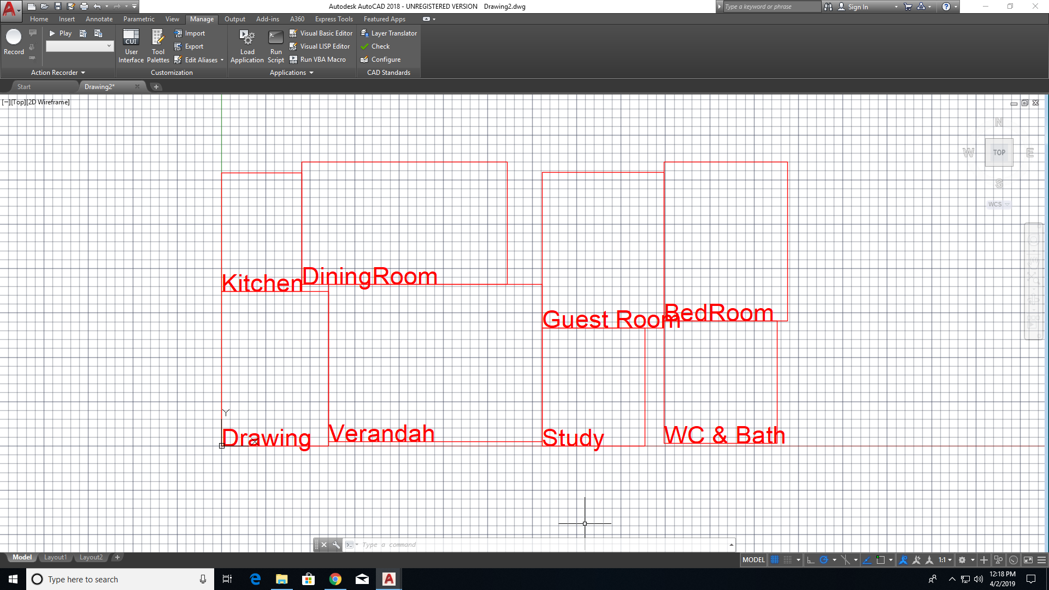

100Unique Fitness Population 1

164.4

175.84

max fitness_value chromosome 188.998186.998(((6 2) (3 5) (4 7) (0 1)) ((6.02822 4.52417) (11.9506 12.0373) (6.0001 6.86265) (6.96352 6.38577)) ((8.69447 6.69572) (6.90088 8.84775) (6.66131 8.74984) (8.9553 6.90622)))(6.02822 4.52417 11.9506 12.0373 4.43743 6.86265 6.96352 6.38577)

(8.69447 6.69572 6.90088 8.84775 6.66131 8.74984 8.9553 6.90622)

((6 2) (3 5) (4 7) (0 1))

((6.02822 4.52417) (13.2798 18.0656) (22.503 24.9282) (31.8917 31.314))31.8917LArea478.16888 31.80111

((6 2) (3 5) (4 7) (0 1))188.998

(6.02822 4.52417 8.75564 12.0373 4.43743 6.86265 6.96352 6.38577)

(8.69447 6.69572 6.90088 8.84775 6.66131 8.74984 8.9553 6.90622)